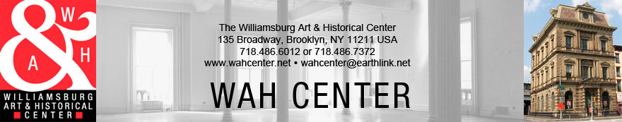
Instruction Details for Accepted Works
“Queer WAH”
Curated by Richard Sanchez

Show Dates: Saturday, October 3rd- Sunday, November 1st
REQUIREMENTS FOR ACCEPTED WORK:
- A completed entry form (please see attachments)
- Paid submission fees: $20 submission fee for 1 piece, $5 for each additional piece. The maximum number of submissions is 3.
- Please have work signed (and numbered, if applicable)
- Accepted works should be framed (unless otherwise arranged)
- A label must be affixed to the back of the work, indicating which end is the top and the following: Artist’s Name, Title, Medium, Dimensions, Date Produced, Edition # (if applicable), and Sale Price. This information must correspond to the submitted works listed on the completed entry form
- We do not accept pieces too fragile to handle
- Works cannot be withdrawn before the end of the exhibition

DELIVERY INSTRUCTIONS:
Hand Delivery Dates: Friday, September 25th-Saturday, September 26^{th,} from 12-6pm
Deliver works to side entrance on Bedford Avenue:
- Ring bell for admittance
- Bring artwork to the 2nd floor gallery & check in at reception desk
- Artwork must be clearly labeled on the front and back
- Take all wrapping materials with you, as we do not have additional storage space

If shipping works, please arrange to have them delivered no later than Saturday, September, 26th
Shipping Address: WAH Center Annex Office, c/o Yuko Nii, 344 Grand Street, #3, Brooklyn, NY 11211
Please include a return shipping label to ensure timely delivery of your works. If using FedEx, please only send barcoded shipping labels with your work.

EXHIBITION BINDER:
For viewers interested in knowing more about the exhibiting artists, we compile an exhibition binder containing information of participating artists. We ask for the following in plastic protective sheets (USA standard 8.5" x11” with 3 punched holes):
- Current resume (limited to 2 pages) with name, school affiliations (if any), past exhibition history (if any), and any past awards or art memberships. Do not include any contact information
- Artist’s Statement (limited to 1 page)
- 2 images of additional artworks not included in the show

PICK UP DATES:
WORKS MUST BE COLLECTED ON Sunday, May 17^{th,} 6-9pm OR Monday, May 18th, 10-4pm
If work is not picked up by specified date, Artist is subject to $10/day storage fees.
The WAH Center is not responsible for works left after 30 days.

