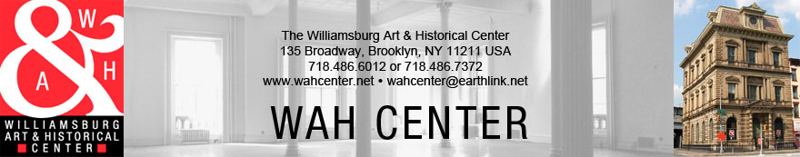
“Queer WAH”
Curated by Richard Sanchez
ENTRY FORM (Deadline: Sunday, September 20th)

Name____________________________________________________________________________________________
Address__________________________________________________________________________________________
City___________________________________________ State___________________ Zip Code___________________
Phone_____________________________________ Email_________________________________________________
School_____________________________________ Expected Degree / Graduation Year _________________________
Work #1 Title_____________________________________________________________________________________
Medium___________________________________________________ Dimensions_____________________________
Date__________________________ Edition________________________ Sale Price____________________________
Work #2 Title_____________________________________________________________________________________
Medium___________________________________________________ Dimensions_____________________________
Date__________________________ Edition________________________ Sale Price____________________________
Work #3 Title_____________________________________________________________________________________
Medium___________________________________________________ Dimensions_____________________________
Date__________________________ Edition________________________ Sale Price____________________________
The WAH Center may sell the above work at the stated sale price and keep as commission 40% of the sale price stated on the entry form. Although the WAH Center will take all regular and customary precautions against loss or damage of the works lent by the artist(s), the WAH Center cannot be held responsible for loss or damage of those works. If the artist chooses to maintain his or her insurance, the WAH Center must be supplied with a Certificate of Insurance naming the WAH Center as an additional assured. Works must be collected on specified pick up dates (Sunday, Nov. 1st from 6-9pm or Monday, Sept. 2nd from 10-4pm) or artist may be subject to storage fees of $10/day. The WAH Center is not responsible for works left after 30 days.

*The WAH Center reserves the right to maintain exhibition quality, all accepted works may not be included in the show, not only because of poor quality, but also due to #1) the limited space, or #2) overall show appearance or #3) too fragile to handle, or #4) In case there is a significant discrepancy between the submitted image and actual work, we may not accept art that does not meet our standards or #5) Work is not received by specified delivery dates (by Saturday, September, 26th)
I, the artist/lender, have understood the above and agree to hold the WAH Center harmless in case of damage or loss of my artwork and I understand that the WAH Center will do its utmost to avoid either.

Artist’s Signature___________________________________________________ Date______________________

